The 10 Days of Giving Spirit!
Monday Nov 28th  Donation theme: Soup (canned soups, dry soups)  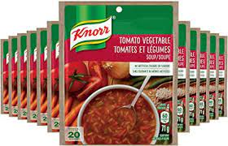  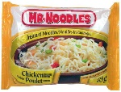  Spirit day theme:  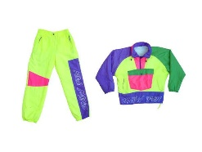  Neon Day | Tuesday Nov 29th  Donation theme:  Beans and Lentils  (dried or canned)  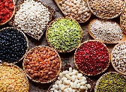  Spirit day theme:  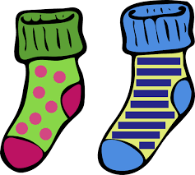  Crazy sock day | Wednesday Nov 30th  Donation theme:  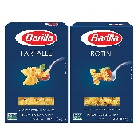  Pasta and Couscous  Spirit day theme:  Come dressed as your favorite animal | 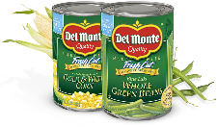  Thursday Dec 1st  Donation theme:  Canned produce  (canned peas, fruit cocktail, canned corn, etc.)  Spirit day theme:  Ugly Sweater - decorate  a sweater, make it ugly! | Friday Dec 2nd  Donation theme: Breakfast foods (Cereal, oatmeal, pancake mix, syrup. coffee, tea, etc.)  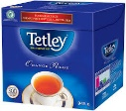  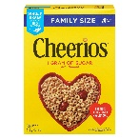  Spirit day theme:  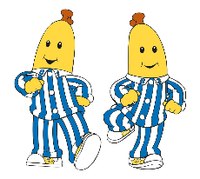  Pyjama day
Monday Dec 5th  Donation theme:  Monetary donation  Spirit day theme:  Bring and share  your favorite book | Tuesday Dec 6th  Donation theme:  Grains (quinoa, rice,  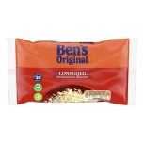  barley, etc.)  Spirit day theme:  Twin day  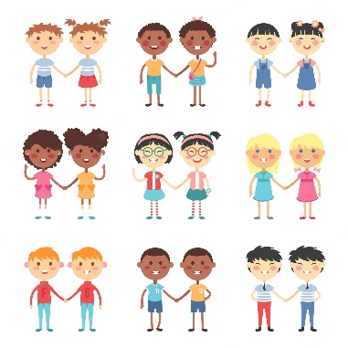 | Wednesday Dec 7th  Donation theme:  Canned meats (tuna,  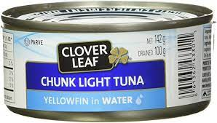  ham, etc)  Spirit day theme:  Blast from the past – Dress like someone from your favorite decade. | Thursday Dec 8th  Donation theme:  Baby/Hygiene products  (diapers, baby food,  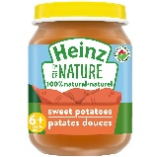  toothpaste, etc.)  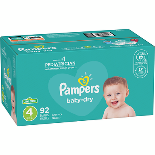  Spirit day theme:  Backwards day  (wear your clothes  backwards or inside  out!) | Friday Dec 9th  Donation theme:  Dry baking ingredients  (flour, sugar, baking soda,  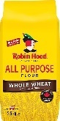  baking powder,  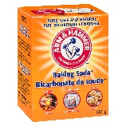  cocoa, etc.)  Spirit day theme:  Pyjama day

Please get ready for our 10 days of Giving Spirit starting on Monday November 28th organized by a committee of École Varennes students. For the next two weeks, each day will have a spirit day theme, as well as a food/item donation theme. Donations are appreciated and will be used to make hampers for families in our community. Any non-perishable food or item donation will be accepted on any day regardless of the day’s theme. Monetary donations will be used to purchase perishable items, toys and any items that may be missing from the hampers. Our community appreciates your generosity!

